**MY REPORT**

**MARKET:**

* In 2019, new car registrations in the EU slightly increased to a level of 15.5 million. Approximately 5.7 million new cars in 2019 were from sport utility vehicle (SUV) segment, 10 times as many as in 2001.
* The share of diesel cars sold in the EU dropped considerably from 44 % in 2017 to 31% in 2019. This is significantly less than in 2011-2012, when 55% of new cars were still powered by diesel.
* The official level of average carbon dioxide (CO2) emissions from new passenger cars in the EU increased to 122 grams per kilometer (g/km) in 2019, which is 1 g/km higher than in the previous year.
* The market share of hybrid electric vehicles (HEV) in the EU was 4 % of all new car sales in 2019. Plug-in hybrid (PHEV) made up about 1% and battery electric vehicles (BEV) about 2% of new vehicle registrations in the EU.

MY GOAL:

* I am doing this project to get and give a proper view on the current and past scenario of engines based on the oil and battery dependent locomotion.
* Then later understand the market of automobile industry in India (for mini) and world (for major project if possible) and the required changes to be done in according to improvement for the market.
* I even tried to get an understanding on the concepts regarding importing and taxation of the crude oil and different companies in Indian market.
* The next thing a learnt is about how a regular ENGINE works in real world and its components.
* Give view and solutions regarding controlling the carbon emission and improve the market for battery dependent automobiles.

ISSUES IN NULLIFYING THE CARBON EMISSION:

* The battery cars are only one of the solutions to control (or) reduce the carbon emission, So I want it to implement at its max potential.
* One of the main issues in the battery cars is the battery itself as the battery has to replaced for every few months and even may get heated rapidly if any malfunctions occur.
* Of course, as compared to the early years of the battery cars we have developed a lot but that is not sufficient as the oil dependent engines provide more development in their engines. Infact the prominent automobile companies are trying to adapt the new technology of battery cars but they have the same issue of improper infrastructure to reach the requirement of the customers.
* Trying to get the most efficient energy sources is one of the major issues. This I want to do in my major project if possible.
* Now the next issue is to provide the availability of the electricity supply as the battery get drained up if we are going to long distance travel, like petrol bunks we have to provide source points to average 10 to 15kms.
* The companies who build the battery cars they have to make effect source of repairing stores in India as this isn’t America (or) Europe where people line up in front of the service station for each company.
* The companies have another challenge is to make the first choice to be the battery car over the regular diesel (or) petrol cars.

My Inputs (or) Solutions:

* The companies should invest a huge amount in the area of research for battery’s basic component lithium and try to find another alternative element for the same purpose. I would like to give my report on the battery in my major project.
* The companies must try to create more efficient renewable energy sources. I have a small report (or) notes on it which I took from different sources.
* The companies should make few contracts with the already present infrastructure like petrol bunks to provide required energy supply. As of in the metro cities in India they we can use many metro points to charge our requirement.
* But as I told the source of this electricity shall also be non-carbon emission process as much as possible. Its funny that the battery charging points are using diesel generator to create the electricity, then there is no use in the battery cars only.
* 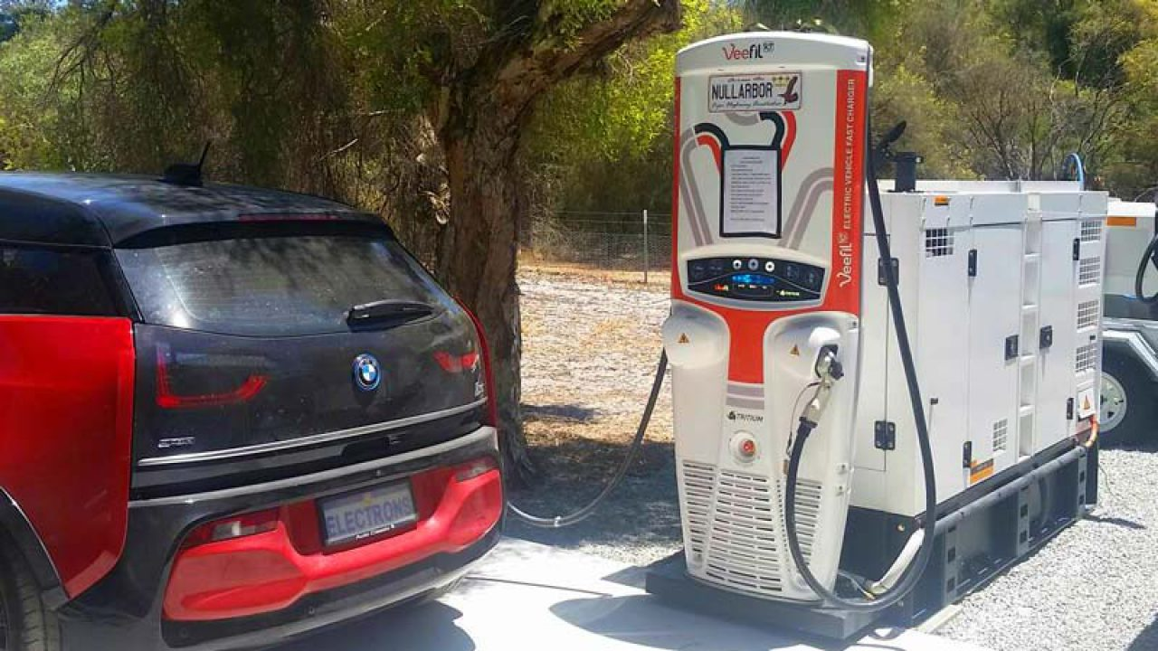
* To create more profits the Indian government is providing some tax reduction in the battery car manufacturing, so this leads to the reduction cost of each car in the near future this might boost the market of people buying the battery cars in coming future.
* For any company in any industry the company has to provide a quality product and the most reasonable price as possible. The four wheelers market in India is already too small as compared to the two-wheeler. But the good news is the market for the four wheelers is growing almost every year, So the companies have to take some time to stand out in the competition as this is not an American market, they got to deal with different approach.
* The famous automobiles like Harley-Davidson was one of the most bankrupt company which could not reach to the lifestyle of Indians. The reason for the failure too high price of the bike as compared to its opponent company like Royal Enfield which was able to attract with there strong bikes at almost have price that of the Harley.
* India we have Tata, Mahindra, Suzuki and many more if any new company wants to come into the market they got to provide a unique product or focus on the specific customers.
* I propose to initially focus on the metro customers as the market is rising these areas for the last 5 to 10 years then move into the towns and the days move on rather than one day show all over the country.
* I hope we can invest more of our energy towards a carbon emission less society. But we have taken the example of how our efforts on the diesel and petrol engine has given use the result of increase in milage and reduced emission carbon over years, but the no of users have multiplied enormously over years which is effecting our evironment.